HOLIDAY WORKSHEET-1
CLASS: VII SUBJECT: MATHEMATICS

- ACTIVITY

- Make a chart and paper work on coordinate pair and four quadrants.
- Make a paper foldable for Rations and proportions.

- CASE STUDY PROBLEM:

- Mrs. Kamal onws two bakery stores in the city. She compares the sales of both the stores and compare the sales by using the bar graph. Yellow bar represent 1st store and grey bar represent 2nd store. Using the bar graph answer the below questions.

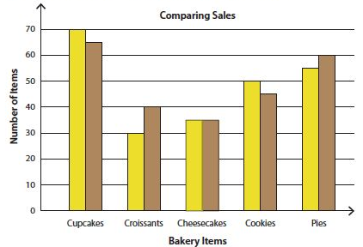

- How many cheese cakes are sold in 2nd store?
- Which store sale more cookies and how much?
- Which store sale more cupcakes and how much?
- How much croissants sold in 1st store?

- REASONING SKILL:
- Suppose, you have 10 apples and 10 friends. You give each of your friends' one apple. Now all your friends have one apple each. But there is still an apple left in the basket. How is this possible?
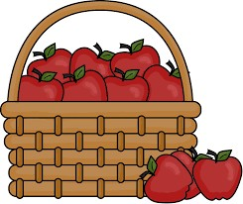
- ARITHMETIC SKILL:
- What is the value of 𝐱 in the following figures?
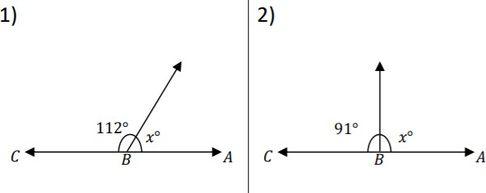

- Use the parallelogram to answer the question below.
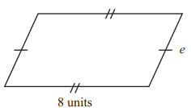

The perimeter of the parallelogram is 28 units. What is the length of side e?

